The Impact of Speed Cameras on Reducing Road Traffic Accidents in Singapore and Accident Hotspots Analysis

Name
Date
Course

Result and Discussion
Map representing the spatial distribution of accidents in Singapore
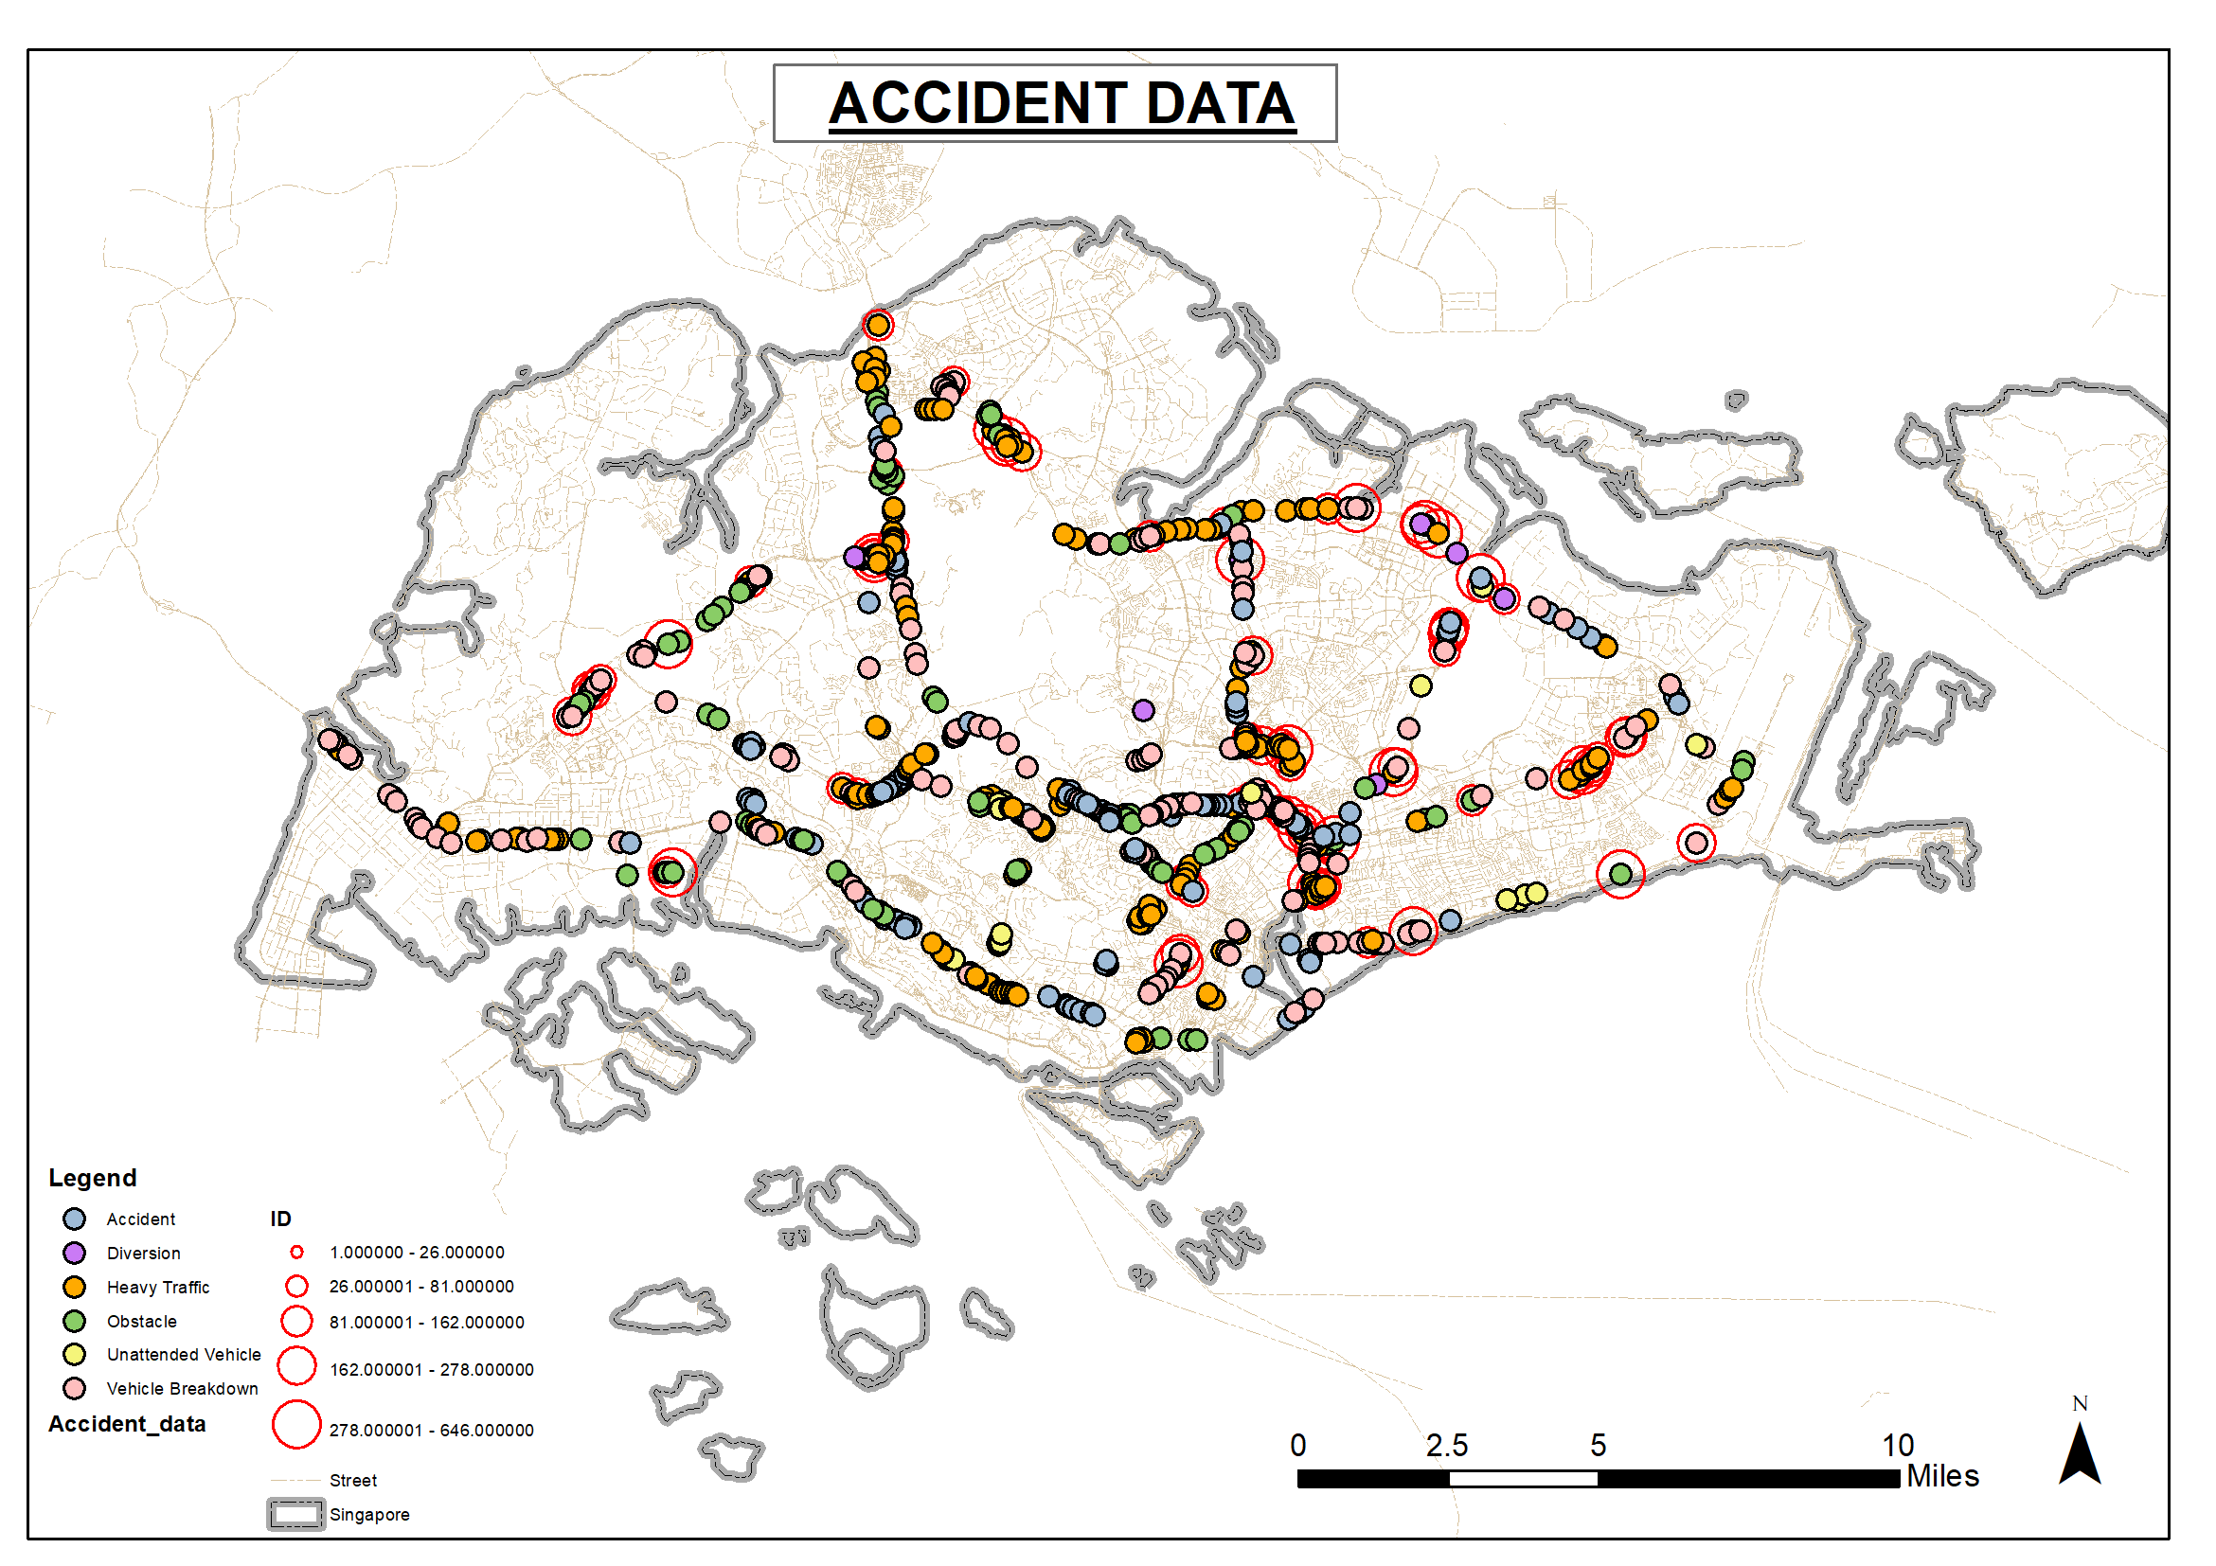
Camera locations in Singapore.
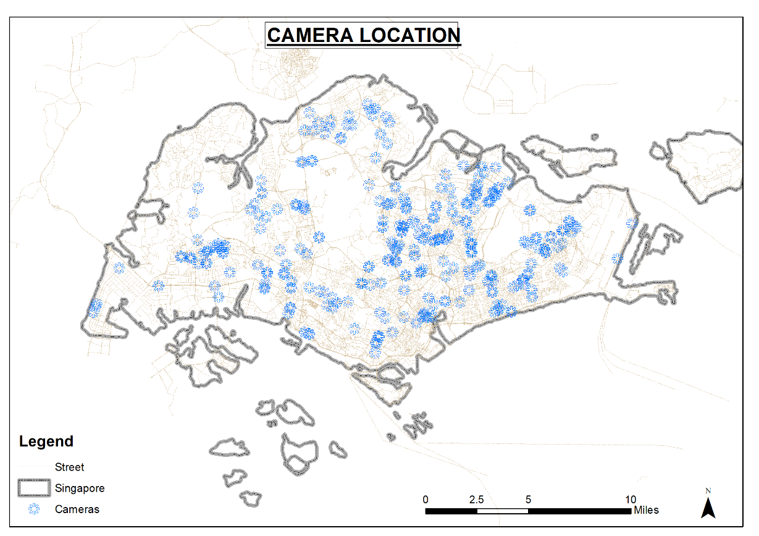
- To assess the effectiveness of speed cameras in preventing and reducing road traffic
accidents.
The number of traffic incidences of accidents and deaths has significantly declined in Singapore as reported by the Singapore Police and the ministry of Home affairs. The decline can be attributed to many other factors such as the addition of cameras on the roads that enhance police surveillance and that trigger the population to be careful. To understand the effective of cameras, the did an optimized hotspot analysis to identify areas with a high occurrence of traffic accidents. The accident data was mapped and classified based on the dwelling units to provide a spatial extent.

Figure 1: A graph showing the number of accidents reported annually,

A hot spot analysis, Getis-Ord Gi* (G-I-star) was applied on the dataset. The analysis evaluated the areas with a high potential for correlated accidents that was indicated with red. The cold spot areas show clustering but lack a relationship between the type of accident and therefore it does not pass as a high correlation. The data analyzed returns a p-score and a z-score for the findings. A high z-score and a low p-value indicates a significant hot spot area while a low z value and a low p value indicates a cold spot area. A z value tending to 0 has no significant spatial clustering as shown in the map below. The areas in red have a high occurrences of accidents that are related and to understand if the cameras influence the occurrence of accidents, we will need to map the correlation between the camera position and the significant hot spot areas.
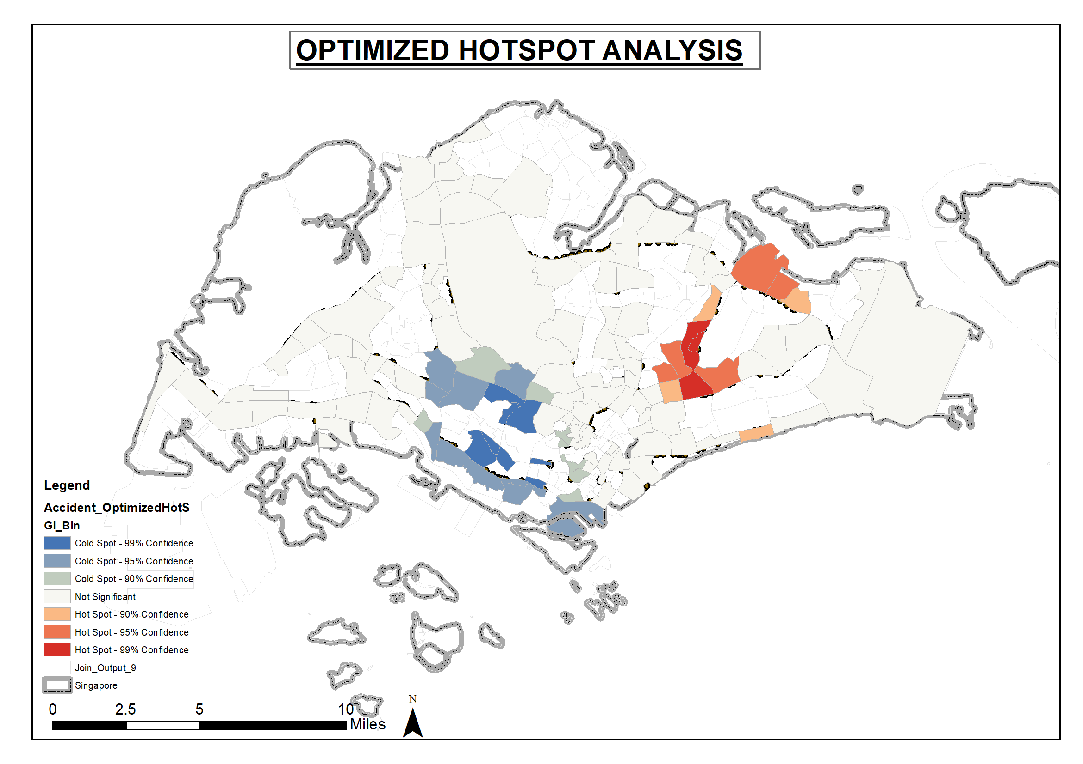
Figure 2:A map showing a hotspot analysis of traffic accidents Singapore
- To spatially investigate the adequacy of speed cameras in Singapore.
To understand the impact of the camera location in Singapore, the camera locations were mapped to represent the spatial extent. A service area analysis was done on the spatial coverage of the camera on a linear path that was estimated to be one mile along a straight road. The service area was mapped to analyze the areas of coverage that are well served by the camera as shown in the map below. The map articulates the coverage along the main street networks where the cameras are located. Another assumption taken for the study is that the camera has a 360 degree view thus it can pick data from any street approaching the main street location. As seen, about half of Singapore has good coverage by the existing camera infrastructure, however, there is a significant part that has no coverage. Notably, the cameras were installed in areas with high traffic incidences in the first phase and evidently there has been a decline in traffic incidences.
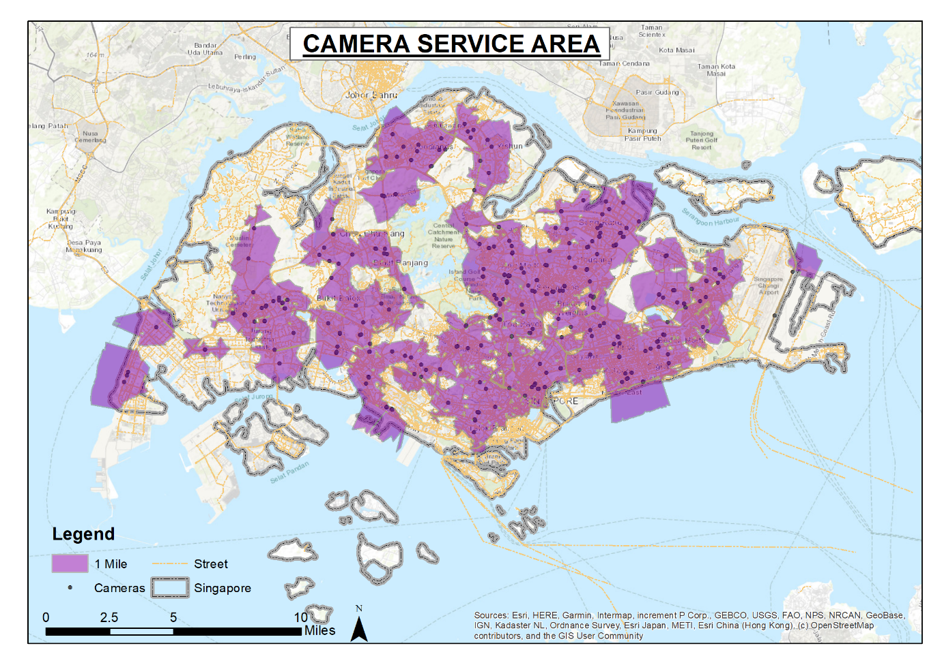
- To identify hot spots for traffic accidents in Singapore.
This analysis evaluated accident data from Singapore and mapped it using a heat map to show areas with high incidences of traffic accidents. The analysis is a visual representation of areas with high cases of traffic accidents in Singapore using a darker shade of deep red and the lighter area have low to zero accident recorded. The data reveals that the main hotspot areas are along major road infrastructure. The high incidences could be attributed to the high traffic volumes within these roads and the knowledge that these routes have high speed limits which could have high incidences of traffic accidents. The map was normalized with the location of the camera points, however since they are spatially distributed around the street network fairly adequately. The high prevalence of accident around the southern art however will require urgent action as the numbers are high and this has a significant impact on the wellbeing of the population.

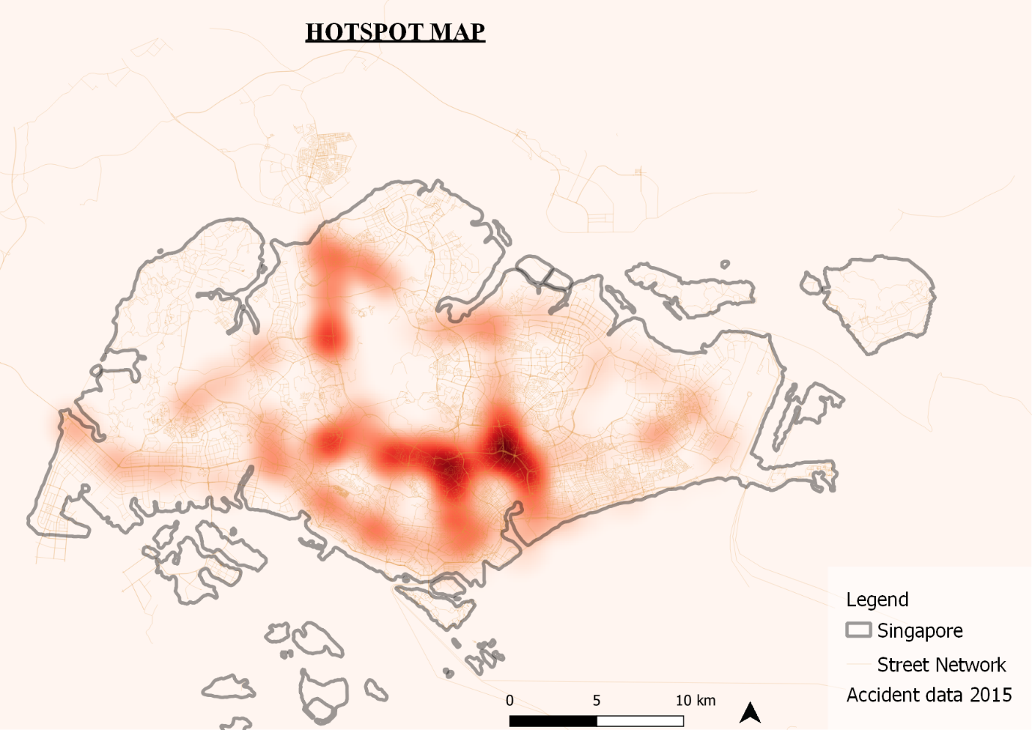
Figure 3: A heat map showing the spatial distribution of traffic accident corelated with camera positions.

- To investigate other measures of reducing road traffic accidents in Singapore
The final outlier analysis done on the accident data is to establish the relationship between the clusters of datasets in the analysis to establish if the traffic accidents are related, to what extent to initiate the right action for reach area. The Cluster and Outlier Analysis supports in the identification of areas with an interesting spatial pattern regarding traffic accidents. It helps in identifying areas with a significant cluster and it proceeds to define the type of cluster relationship, more than the hot spot analysis. The analysis maps areas with significant data that coincides with significant outliers as well. The analysis reveals two areas of significance for the study, the low high outlier and the high low outlier that shows both extremes in terms of accident with no correlation, and accident with significant correlation. The finding points out to significant high number in areas with low camera coverage.
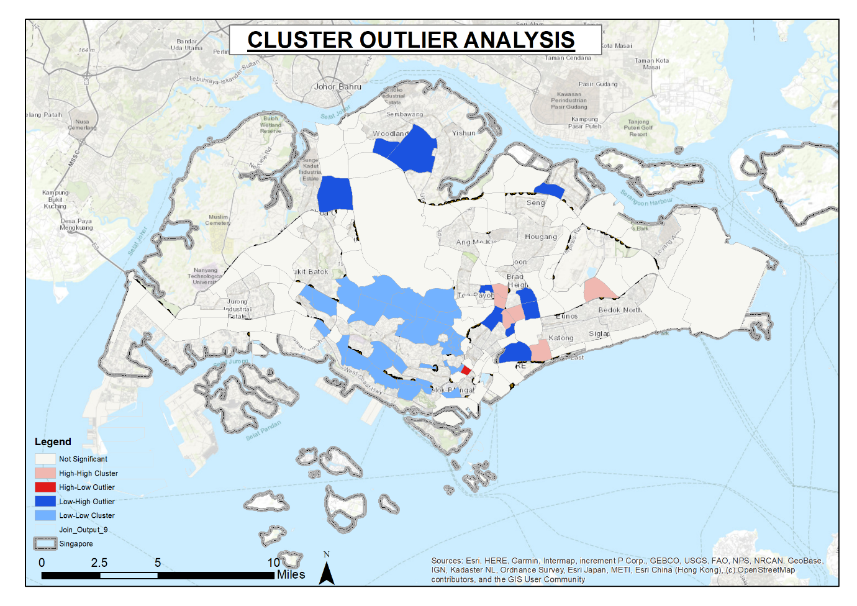
Figure 4: A map showing the Cluster and Outlier Analysis for traffic accident in Singapore
Recommendation
The analysis on Singapore reveals a thought-provoking pattern on the spatial distribution of traffic accident. First, is that most of the accidents reported are along major highways and they are clustered as either accidents or heavy traffic. In this analysis, the accident data was widely used for the analysis and to establish of the Camera help in reducing his numbers. Notably, there is a significant decline in traffic accidents in areas with Camera and the final map reveals gaps in the Northern part in relation to the camera positioning. The number of accidents however remain high towards the south and it an be attributed to several factors, that If addressed will support the reduction of traffic accidents. The area requires placement of adequate cameras to capture roads that are limited with curves and junctions. Secondly, there is need to provide public awareness on the factors causing accidents along the routes to ensure the improvement in reduction of accidents. Additionally, since there is limited data on the causes of these accidents on the ground, there is need to do a site specific study by sending researchers to gather relevant data for the key areas identified to improve on the action taken for each site specifically, in the bid to reduce traffic accidents.

References
Gundooglu, B. (2010). Applying linear analysis methods to GIS-supported procedures for preventing traffic accidents: Case study of Konya. Safety Science, 48 , pp. 763-769
Mitchell, A (2005). The ESRI Guide to GIS Analysis, Volume 2. California, ESRI Press.
Sharma, A., and Li, C. (2017). Exploring spatio-temporal effects in traffic crash trend analysis Analytic Methods in Accident Research, 16, pp. 104-116

