Hospital Accessibility Using GIS
Student’s Name
University Affiliation
Course/Number
Date
Table of Contents
List of Figures 3
Executive Summary 4
1.0 Introduction 6
1.0.1 Public and Private Healthcare Systems. 6
1.0.2 Institution and Statutory Boards. 7
1.0.3. Healthcare Funding. 9
1.1 Project context or project concept 13
1.2 Terms of reference 15
1.2.0. Objectives of the Study 15
1.2.0.1. Main Objectives 15
1.2.0.2 Specific Objectives 15
2.0. Approaches and data availability 16
2.0.1. Data Availability 16
2.1 Evaluation of existing tools (or software) and data with respect to the term of reference. 18
2.2 Project workflow and its timeline (milestones) 19
3.0 Result or deliverables 22
3.1 Discussion 31
3.2 Evaluation 32
4. Conclusion 33
4.0. Recommendations 33

List of Figures
Figure 1: Health Clinics in Singapore 23
Figure 2: Health Clinics and Population Blocks 25
Figure 3:Thiessen polygon for health clinics 26
Figure 4: Hospitals and Clinics Thiessens 27
Figure 5: Buffer distance for health clinics. 28
Figure 6:Network Analysis for Health Clinics 29
Figure 7: Proposed new locations for health clinics. 30
Figure 8: Comprehensive route analysis for incidences 31
Figure 9: The most suitable route. 31

Executive Summary
In general, accessibility to primary healthcare is vital to national healthcare particularly for older people in the society where the population is rapidly aging, for instance in Singapore. A lot of research has been carried out and policies have been made in this area to assess the accessibility of primary healthcare services. However, accessibility of healthcare services varies across time and space hence it is affected by where people stay and the location of healthcare experts.
The accessibility of medical care and health services is defined by the supply of manpower, facilities, and cost. The Obama administration healthcare team has reviewed Singapore's healthcare system and termed it as a world-class system. The system was ranked as the best in Asia by the World Health Organization in the year 2000, ahead of Japan and Hong Kong. Healthcare in Singapore is managed by the government and the ministry of health. Paying of the healthcare cost is done through cost-sharing, government funding, and national healthcare insurance. Generally, the country has a widespread and efficient healthcare system
A report released by the World Health Organization in the year 2010 ranked Singapore in position six out of one hundred best healthcare systems in the world. In 2014, Singapore’s healthcare system was ranked by Bloomberg as the most efficient in the world. Moreover, the country was ranked number four out of one hundred and sixty-three countries by Bloomberg Global Health Index as the healthiest country in the world and number one across Asia. Moreover, the country is also ranked number one on the Global Food Security Index. Singapore has the longest life expectancy estimated at eighty-four years, as of 2019. The average life expectancy for men is a little bit lower compared to that of women who are expected to live an average of eighty-seven years with seventy-six years in better health.
To enhance the accessibility of the healthcare system in Singapore, a geospatial information system (GIS) will be used. GIS represents a framework for gathering, managing as well as analyzing data. This therefore makes it easier to capture as well as to analyze the geographic and the spatial data. The needs to enhance the geospatial analysis capabilities as well as monitoring helps in assessing the accessibility of the healthcare services by the citizens. The accessibility of the healthcare is a function of several things which include geographic distances to service locations, the available modes of transportation and the travel time. The accessibility data will be very vital in planning for improvements. Moreover, the expansion of the healthcare infrastructure is pegged on the accessibility of the health care services. Besides, assessing the accessibility of the heath care institutions can help when redesigning the public transportation routes which will be used to enhance the healthcare services. This paper thus serves to discuss the accessibility of the healthcare systems in Singapore and how it can be improved. To effectively achieve this, various analysis will be performed which include spatial analysis, buffer analysis, thiessen polygons analysis as well as road network analysis.

1.0 Introduction
The Joint Commission International (JCI) has accredited twenty-two medical facilities and hospitals in Singapore. Basically, any type of medical treatment that people may need is available in the country with high-quality service and a reasonable cost. In Singapore, the healthcare system comprises of both private and public facilities offering medical care of high quality but in a distinct level of comfort and service (Haseltine, 2013). The insurance services, health plans, and benefits differ greatly as they all depend on a person's employer and immigration status. The permanent residents and the Singapore citizens are entitled to government health services which are subsidized through compulsory savings schemes referred to as Central Providence Fund (CPF). For the sake of immigrants who have work permits, they acquire healthcare services by purchasing privately or through their employers.
In the provision of health insurance benefits, it is not mandatory for employers in Singapore to give the service. Big companies in the country have a higher probability of providing health insurance benefits to their employees. According to Haseltine (2013), Singaporeans are provided with subsidized healthcare services by the government healthcare facilities. These facilities comprise of numerous polyclinics providing outpatient and a number of government hospitals offering inpatient services. Public hospitals although owned fully by the government operate as private entities so that they can compete with private facilities on quality and service (Haseltine, 2013).

1.0.1 Public and Private Healthcare Systems.
Healthcare facilities owned by the government not only provide quality services to people but also takes care of the most complicated cases referred from the neighboring countries and other hospitals. Furthermore, the government health system at times decides to set the benchmark for private healthcare in order to compare the medical standard professionalism and fees. The government specifically effects on long term trends for example the introduction of high technology, high-cost medicines, and supply of hospital beds. This makes the cost in public hospitals increase hence setting the benchmark with respect to pricing for the private hospital. The government subsidizes the charges in public healthcare but in the outpatient clinics and the private hospitals, patients pay doctors on a service basis and also pay the total amount charged by the hospital.
The government modifies policies on a regular basis in order to regulate prices and the supply of healthcare services. This means that the government can introduce a new healthcare setting in instances where the demands surpass the supply. It is however critical to note that the government does not regulate the cost of medication in private facilities (Kumar, Ozdamar & Zhang, 2008). The cost varies within the private sectors because it is largely subject to the market forces and also depends on the service provided and medical specialty. The Singapore healthcare system is unique making it difficult for other countries to replicate.
The private healthcare facilities in the country are good with outstanding levels of services and medical care. There are special policies and procedures which guides the establishment of the private hospitals. For non-citizens, the difference between private and public healthcare facilities in terms of cost is negligible due to the competition with each other. Due to the fact that private facilities offer better level of service and there is minimal waiting time to see the doctor, most of the people living in Singapore prefer to visit private healthcare facilities (Haseltine, 2013).

1.0.2 Institution and Statutory Boards.
Singapore’s healthcare system is divided into institutions and statutory boards. The statutory boards in the country include the dental council, medical council, pharmacy council, opticians and optometrists, and nursing board. Healthcare institutions are classified as private and public healthcare facilities. Since the 1990s, all healthcare facilities in Singapore have been designed as government corporations. They all work under three healthcare groups namely SingHealth, National Healthcare Group, and National University Health System.
The ten government hospitals consist of eight general hospitals which include Singapore General Hospital, Alexandra Hospital, Tan Tock Seng, Changi, Khoo Teck Puat, Sengkang, and Ng Teng Fong hospitals. Also, there are two specialized hospitals namely the Institute of Medical Health (IMH) and KK Women's and Children's hospitals. For the treatment of certain diseases, there are nine centers. For cancer treatment, the hospitals include the National University Cancer Singapore (NCIS) and the National Cancer Center Singapore (NCCS).
The healthcare facilities for cardiac treatment include the National University Heart Centre (NUHCS) and National Heart Center Singapore (NHCS). For eye treatment, there is the Singapore National Eye Centre (SNEC) and National Skin Center (NSC) for skin diseases. The neuroscience has a center called the National Neuroscience Institute (NNI) and for dental care, there are National University Center for Oral Health Singapore (NUCOHS) and National Dental Center Singapore (NDCS). Singapore had a total of over ten thousand medical doctors by 2012 in her healthcare system. There were also more than thirty-four thousand nurses including midwives with a ratio of one nurse to one hundred and fifty people. The dentists by the same year were more than one thousand five hundred with a ratio of one dentist to three thousand two hundred individuals.
According to the research, almost eighty percent of Singaporeans gets their medical care in the public hospital, unlike foreigners who mostly prefer private facilities (Kumar, Ozdamar & Zhang, 2008). Public healthcare spending by the government amounts to at least 1.5% of the annual Growth Development Product (GDP). This means that each person is entitled to at least one thousand one hundred dollars annually through Government Health Expenditure. Education and defense ministries are the most spending items in the country and health spending is ranked at number three. The country’s health spending is expected to increase as the median age of the population grows. The healthcare expenditure had increased to at least nine billion dollars in 2016 from four dollars in 2011.
Over management decisions, the public hospitals have the freedom and there is competition among them for patients. General hospitals have diverse services and functions as they represent specialist outpatient and acute inpatient services. They operate 24 hours and have emergency centers that specialize in precise medical fields such as dental care, cardiac care, neuroscience, cancer research, and so on. The country has a number of hospitals available and intermediate healthcare for persons who do not need the services of general hospitals but cannot manage to stay at home.

1.0.3. Healthcare Funding.
Singapore’s public healthcare funding can be broken down into MediShield Life, MediFund, MediSave, and the ministry of health. The Civil Defense Force (SCDF) offers the Emergency Medical Services in the country. The defense force is categorized as a nationally funded emergency medical service system. In 2013, the force responded to at least one hundred and fifty calls in which ninety-six percent were regarded as emergency calls.
MedSave which is a healthcare funding is an account under a person’s Central Provident Fund that assists people in payment of medical insurance policy premiums and upcoming medical expenses. Money in this account can be used by people in the whole extended family. The board of Central Provident Fund allows Singaporeans to set aside funds to be used in healthcare, retirement, and mortgage. People can contribute on a monthly basis to three accounts which are different. The first account is ordinary accounts for insurance, investment, housing, and education (Kumar, Ozdamar & Zhang, 2008). The second is special accounts for investments and retirement and the third is a MediSave account for medical insurance and hospitalization expenses. The contributions for MediSave are generally between eight to ten percent of a person’s income. All workers are required to have a health savings account and the individuals who are below fifty-five years are needed to deposit twenty percent of their income. The employer contributes seventeen percent of the employee’s income.
MediShield funding was established in 1990 and it is basically used by individuals who are not able to meet their medical expenses due to insufficient savings. Its premiums are paid as of those of MedSave accounts. In 2015, the month of November, MediShield was replaced by a new scheme called MediShield Life. The scheme assists in setting hospital bills and few outpatient treatments. Lower to middle-income population are provided with premium subsidies by the government while the new policy holders and the elderly transitioning from low-priced policies (Khoo, Lim, & Vrijhoef, 2014). Private insurance coverage and MediShield components contain Integrated Shield Plan (IP) that is managed by private insurers to cover benefits that are optional in private and public hospitals. The Integrated Shield Plan premiums are paid by the MediSave funds.
Eldershield is an insurance scheme for people living with disabilities and caters to the cost of private nursing homes and other related costs. People aged forty years and have the MediSave account are enrolled in the scheme automatically since 2002 unless they decide to opt out. Three private insurance brokers which include NTUC Income, Great Eastern, and Aviva were selected to supervise the Eldershield. By 2021, the ministry of health will take over the scheme from the three insurance brokers and manage it on a nonprofit basis. The plan will let a smooth advancement to CareShield Life.
MediFund is the country's security net program that only covers the lowest class of services and hospitalization fees. The insurance coverage is available to Singaporeans only when they have exhausted their MediShield and MediSave funds. The funding amount is dependent on the persons’ socioeconomic health condition and income status (Haseltine, 2013). The fund is endowed by the government to support those who do not meet their contributions which they have been evaluated for. People may find themselves in tragic expenses since the risks are not pooled. In the year 2015, more than one hundred and fifteen dollars were assigned to patients.
Permanent residents as well as Singapore citizens admitted in hospitals get subsidies from the government for their medical bills which are scaled with respect to their income and the class of ward. Individuals warded in C and B2 class wards of public facilities since January 2009 go through means testing to decide the subsidy level they are eligible based on the amount they received for the previous twelve months including bonuses. Moreover, patients getting services like day surgery, polyclinic visits, and specialist outpatient do not undergo means testing and thus they receive consistent subsidies regardless of their wages. Subsidy rate for individuals with no source of income for example housewives or retirees is measured to the value of their homes (Haseltine, 2013).
In 2012, there was an establishment of the Community Health Assist Scheme. The scheme offers subsidies to Singaporeans who are classified as lower to middle income earners. The scheme also helps individuals who were born before the 1950s, and are treated for chronic health issues, common sicknesses, and specific dental problems. Orange or blue Health Assist Card is granted to beneficiaries depending on the income of the household. From the year 2019, orange card holders who received subsidies for only chronic issues are also receiving subsidies for common sicknesses. However, all Singapore citizens will receive increased subsidies for complex chronic issues and will be covered for chronic health problems.
Rapid aging is not only faced by Singapore but it is a worldwide population challenge faced by many countries. Healthcare services for the elderly and all people, in general, are critical and should be accessible. The hospitalization bill in Singapore depends on the type of ward. The wards vary from those that are private to the ones which are open with no air conditioners. The country provides unique surgeries to individuals from all over the world at a relatively affordable cost. This therefore calls for government to ensure the accessibility of the healthcare services in the country is improved and enhanced.

1.1 Project context or project concept
The hospitals in Singapore are divided into three categories namely: the general hospitals, specialist hospitals and institutions and the community hospitals (Haseltine, 2013). The general hospitals are entrusted with the provision of acute tertiary care in the country. These hospitals thereby provide compressive care to the patients, allied support services as well as in-house specialists. The second category is the specialist hospitals and institutions. These type of hospitals play a crucial role in the provision of specialist healthcare and treatment. Among the hospitals involved in this category include the medical centers which house independent specialist doctors and clinics. Lastly, we have the community hospitals. These represents semi-public hospitals which cater to coalescing, geriatric and rehabilitation patients. Most of these hospitals are usually funded by religious and charity groups. However, they also receive some assistance from the public healthcare professionals as well as from the government funds.
To measure the quality of healthcare in a given country, one of the critical measures which should be used in the accessibility to medical services (Zhu & Protti, 2009). It is the right of every citizen to have equitable access to the healthcare services in a given country. However, the geographic and economic issue can make it hard for a country to achieve healthcare equity. The country has an obligation of developing the medical infrastructure through paying attention to income, age, race as well as industrial/commercial/residential activities. In Singapore, achieving equity in health care services is one of the priority of its healthcare system as a whole.
Evaluating the healthcare accessibility should be done by evaluating the differences between supply and demand of the healthcare services (Khoo, Lim & Vrijhoef, 2014). The assumptions with this is that all the healthcare facilities in Singapore are offering the same type of services. This will therefore entail proper usage of the population data within the Singapore districts. Measuring the mean difference between a patient’s location and the healthcare supply points will be crucial in determining the supply of healthcare services.

1.2 Terms of reference
The research question served to assess whether the pubic healthcare systems was equal to all the citizens. However, there were several assumptions which were made when doing these analyses. One is that all the public and private hospitals used were serving the citizens in their respective jurisdiction. Furthermore, it was assumed that all the hospitals in Singapore were in a position to offer the same type of services meaning that they had the same type of healthcare facilities needed and the quality of services offered was the same.

1.2.0. Objectives of the Study
The project has two main objectives:

1.2.0.1. Main Objectives
To evaluate the equitable accessibility of healthcare in Singapore.

1.2.0.2 Specific Objectives
- To assess the availability and accessibility of public health care services in Singapore using GIS.
- To conduct a Road Network Analysis to analyze the optimal route which should be used in case of a medical emergency

2.0. Approaches and data availability
To effectively achieve the set objective, various number of analyses will be performed. To evaluate the accessibility of the data, spatial mapping will be done. This will be done to effectively determine the spatial distribution of both the public and private healthcare facilities. It is crucial that the data used is in line with the coordinate system in Singapore (Abdelmajid, Apparicio, Riva & Shearmur, 2008). The generated maps will contain all the major and important cartographic techniques. The first step will be to perform the buffer analysis across all the public and private healthcare institutions. The distance used will be determined by the complexity of the analysis needed. There are various assumptions which are made before conducting the analysis. The second type of analysis which will be done will entail the use of the thiessen polygons. These are usually generated from a set of sample points. Thiessen polygons plays a crucial role in defining an area of influence which is usually across a sample point.
A network analysis will also be done. This will be very crucial in evaluating how accessible the healthcare facilities are. The location allocation will be the analysis which will be used in proposing the location of new facilities. This will be done based on the needs of a given area after evaluating the gaps after performing the network analysis. The chief objective of this project is to evaluate the accessibility of a given facility. This therefore calls for analysis of the routes which will be crucial in highlighting the best and new routes which can be used to access a given facility.

2.0.1. Data Availability
To effectively conduct an analysis, data will be sought from the Singaporeans authorities. One crucial data will be the shapefiles on subzones in Singapore. In addition, the population data will be sought for purposes of calculating the population density in relation to a given facility. To evaluate the accessibility of the facilities, infrastructure data such as the road lines will be used. Moreover, the facilities locations which will be in XML format will be used in this research. This data was readily available from the Singaporean authorities.

2.1 Evaluation of existing tools (or software) and data with respect to the term of reference.
The research process will apply the descriptive cross sectional study. The three stage model will be applied in identifying the high priorities areas. Literature to identify the gaps in healthcare accessibility was got from the existing books, forms and articles. It was crucial to extract indicators which were relevant to the health care services. This called for the evaluation of the standards and guidelines used. The inclusion criterion was used to highlight the necessary literature which will be used in the research process. ArcGIS 10.7 software was used in this research process. This software finds a lot of usage since it supports the spatial placement of a map (Wheeler, 2013). Through applying the set cartographic techniques, this software can help in supporting the cartographic visualization of the data. It will hence be used in conducting the buffer analysis and the thiessen polygons analysis which are crucial in assessing the need of a given service based on supply and demand. The software will also be crucial in performing the network analysis.

2.2 Project workflow and its timeline (milestones)
The aim of the study is to analyze hospital accessibility in Singapore while evaluating the role of GIS in health care management to improve efficiency. To achieve this, several steps and analysis were performed to the data to support the mapping and analysis of the study area. These steps are as outlined:
- Spatial Mapping
The idea of spatial mapping encompasses the spatial distribution of spatial point and representing this on a map (Goodchild, De Smith & Longley, 2015). The first step is to determine the reference system that will be used for the analysis and ensuring that all data is aligned to the selected coordinate system to advance positional accuracy. The mapping was done in the ArcGIS 10.7 software that supports the spatial placement of the map and application of cartographic techniques to enhance the visualization of the data. Cartographic techniques applied include symbology, color changing, legend placement, north arrow allocation and giving a title of what is being represented.
- Buffer analysis
The buffer analysis gives a uniform radius from a point with the assumption that there are no barriers to the radius (Yang, Goerge & Mullner, 2005). The buffer tool was used for the analysis with a buffer distance of 3000 meters to do the analysis. A round buffer with dissolved boundaries where there is an overlap gives a continuous space representation of the areas within the buffer and it served well to generalize areas by distance.
- Thiessen polygon development
The Thiessen polygons, also known as vonoroi diagrams are polygons that are used to identify neighborhoods by applying a proximity analysis to a point data (Wheeler, 2013). The tool allocates space to the area covered just to depict the service area of a facility and it points out to overstretched areas or areas with larger Thiessen polygons that point to areas with gaps.
- Network analysis
The network analysis is a refined approach for analyzing the accessibility of a facility with regards to the network features (Wheeler, 2013). As mentioned in buffer above, it assumes uniformity of the surface. However, for the network analysis it is a more detailed approach and it infers to access through a linear network, either road, or rail. The network analysis supports other functions in its operations in ArcGIS and it is suitable to achieve this using the software. Other analysis that can be achieved through the network analysis are location allocation, new route identification, depicting the service area, determining the closest facility to an incidence, vehicle routing and least cost analysis for a network.
- Location Allocation
Location allocation is a tool under the network analysis that identifies suitable areas for proposing the development of a facility to meet the gaps identified in the network analysis service area mapping. It is achieved by plotting demand areas and analyzing areas to propose suitable locations for new facilities as the demand states. The analysis is good as it gives priority to which facility can be developed first due to the demand by analyzing location of other facilities.
- Route planning
The route planning refers to the identification of the new routes to access a facility or the identification of suitable routes when responding to an emergency (Yang, Goerge & Mullner, 2005). The approach is suitable in the event of emergencies as it models the best route to access the incidence site for ambulances and emergency services and the nearest facility to take the patient in the least time and distance possible.

3.0 Result or deliverables
- To assess the availability and accessibility of public health care services in Singapore using GIS.
- The first step was to map out all the infrastructure and heath care facilities in Singapore as shown in the map below. The map indicates the concentration of health facilities within a certain region or node with a high concentration of the East of Southern part. The scope of the study will be to understand what factors influence the spatial distribution within the study extent. In this step, it is important to note that the data used for the hospitals and health facilities was downloaded from the ministry of health of valid and active health clinics in Singapore. The Northern West part seems to lack any public facility as well as the extreme south west part that has no clinic within its scope.
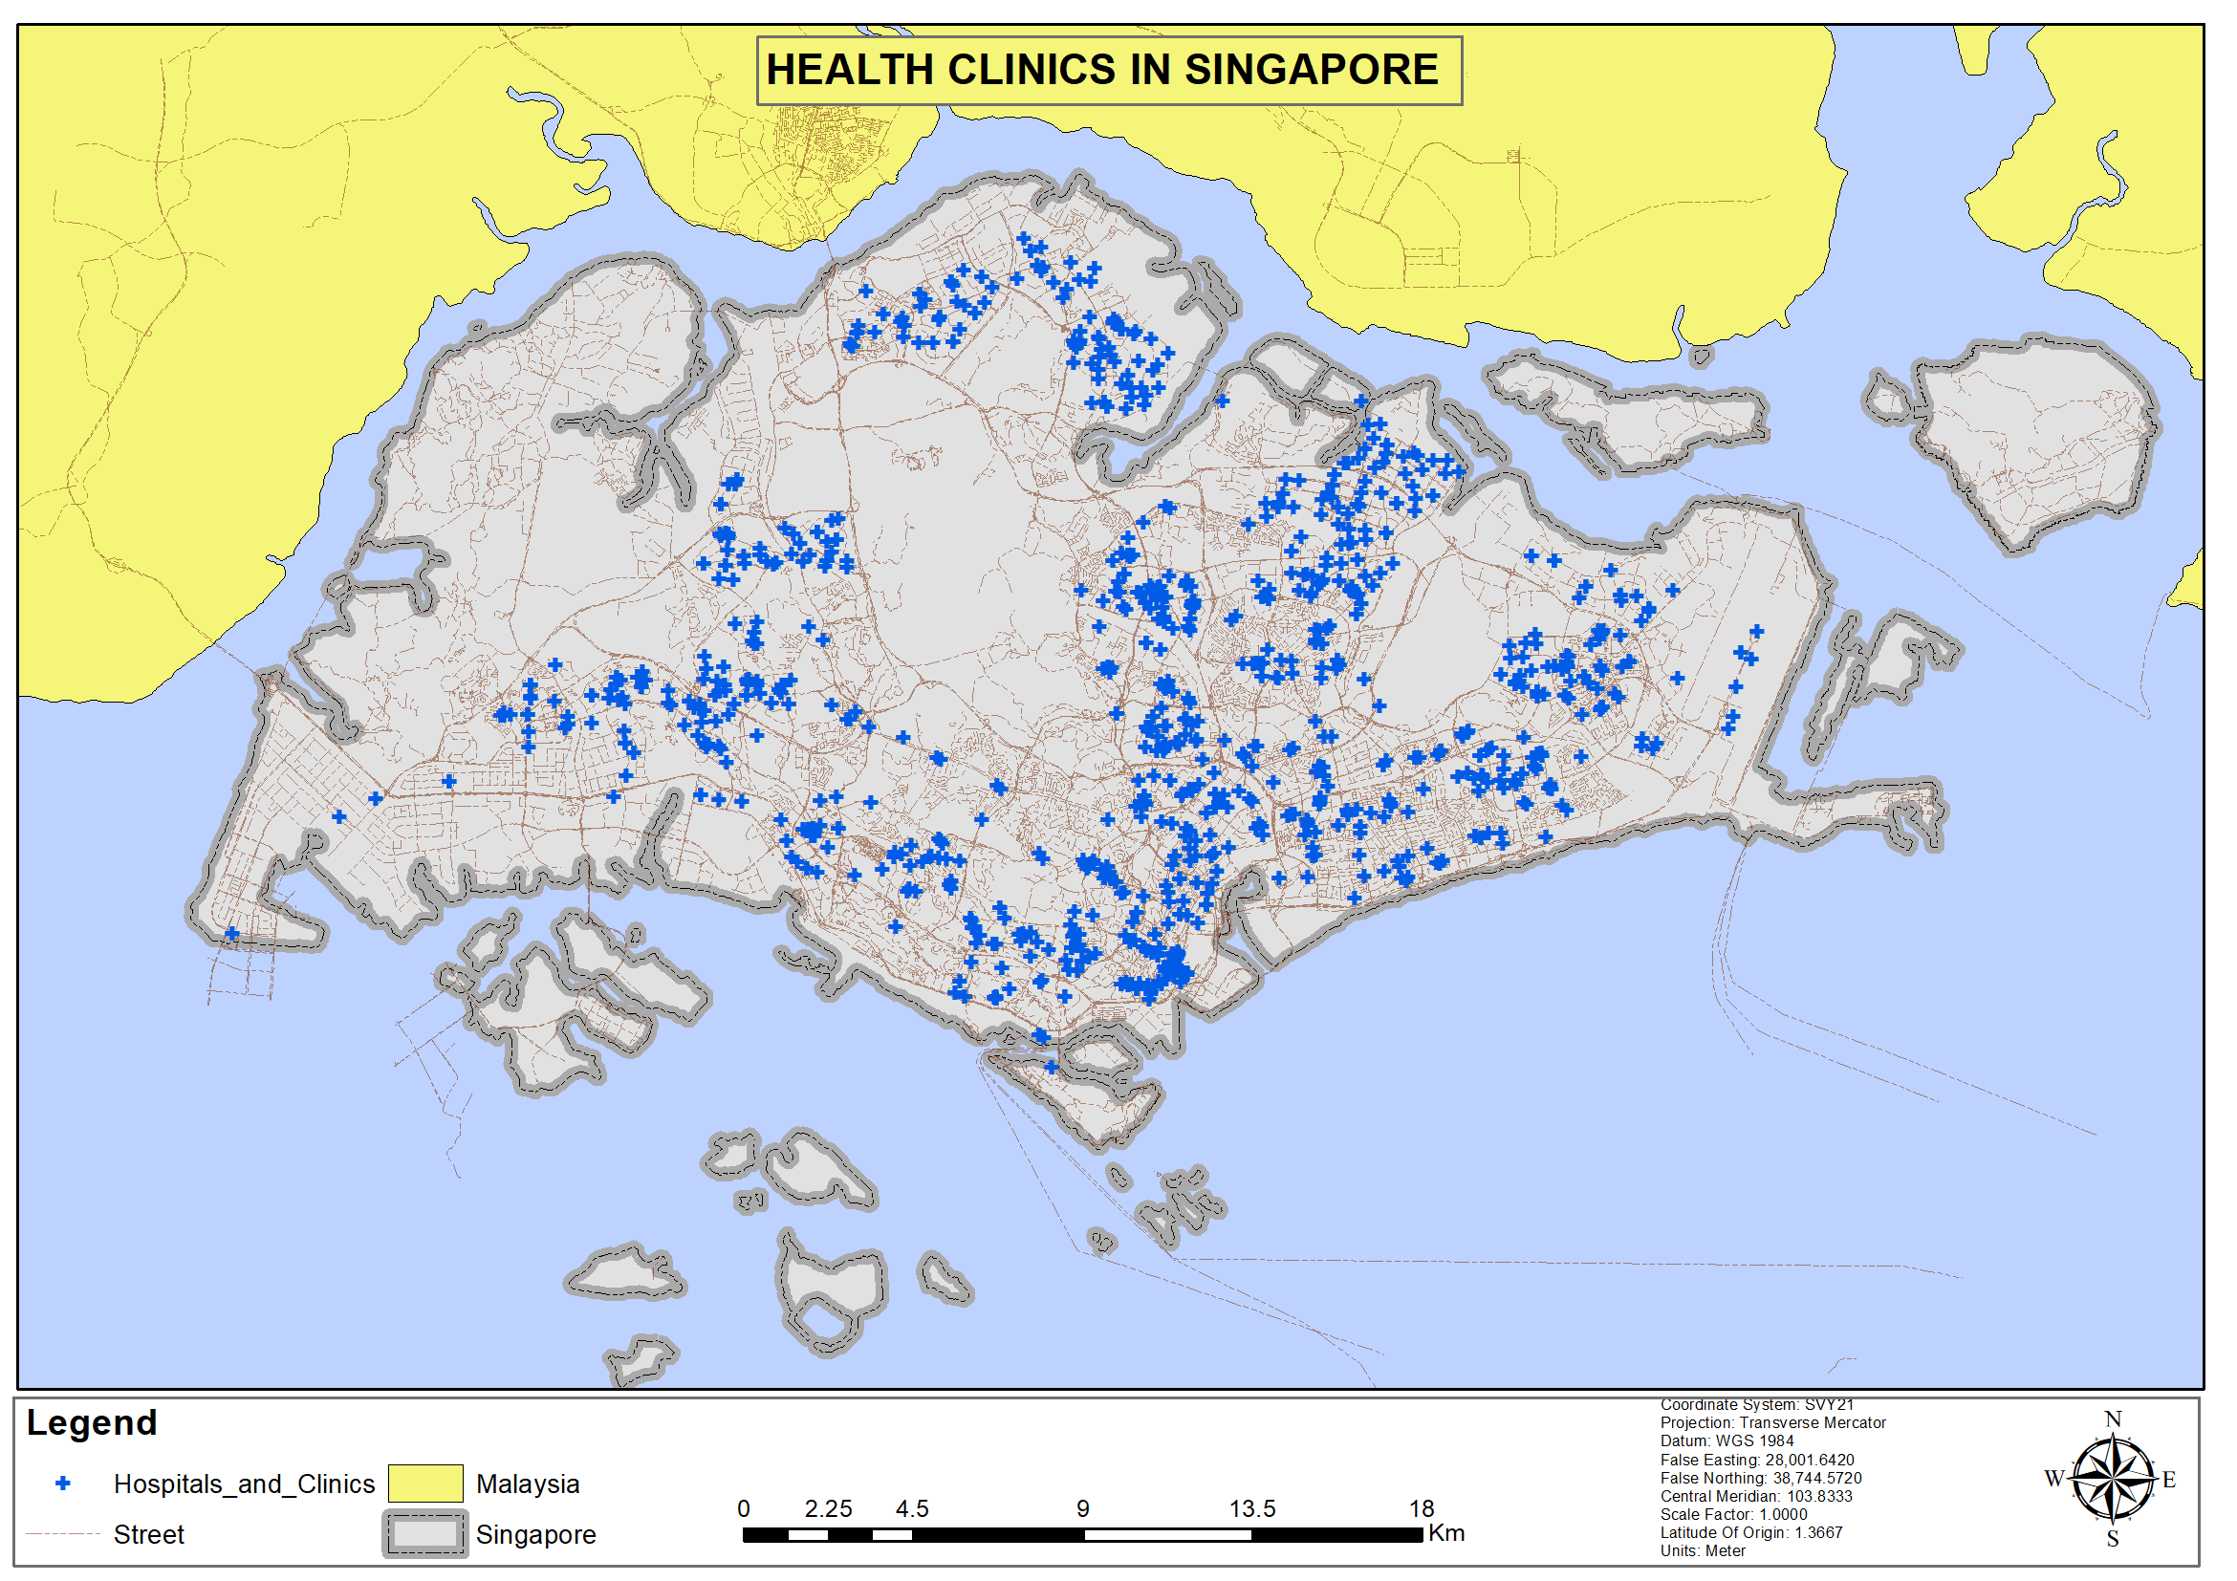
Figure 1: Health Clinics in Singapore
- The second outcome was to visualize the health care facilities locations in relation to the population density of the various regions. The data is developed from the Singapore dwelling unit zones (neighborhoods) that define the number of people within and the number of houses within. To compute the density, the area of the polygon was computed and an estimate of the total population. The population was computed by doing a summation of the dwellings with a calculation of the estimated number of people per dwelling for each of the polygon and the density was computed by dividing the area with the total population.
Population Estimate :
Sum = (dwelling unit * no of people) + n…
with n referring to the number of units provided.
Population Density :
= Total population per block / area of the block in Ha
The outcome of the analysis was mapped below:
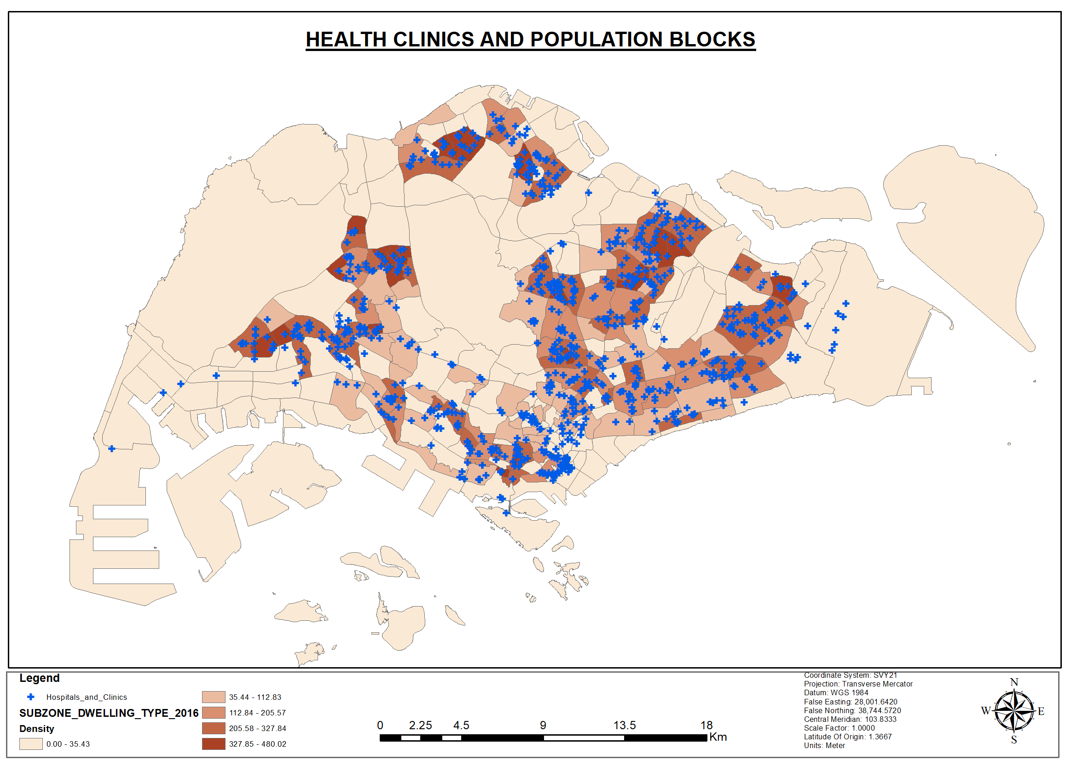
Figure 2: Health Clinics and Population Blocks
The map evidences that the concentration of the hospital is higher within areas with a high density as shown by the deep shade of the color used for the analysis. The population number expounds on the spatial distribution of the health facilities within Singapore.

- The third outcome will contain the health care facilities location with Thiessen polygons with respect to the administrative border. The polygons help to define the area of service that a facility is expected to serve based on its spatial position. The service area for the health facilities with a high concentration is really low compared to the service are of the area with sparse distribution of health facilities, that affect the quality of services.
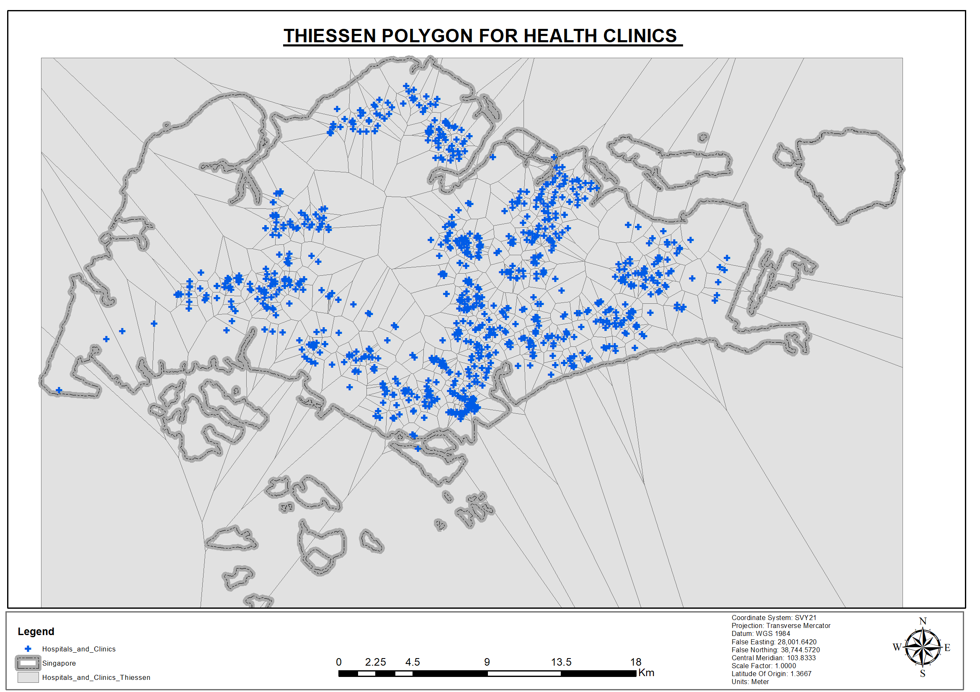
Figure 3:Thiessen polygon for health clinics
As mentioned, the Thiessen polygons help to show the service area and a zoom shows that some Thiessen polygons have a more than one health facility within its extent of service.

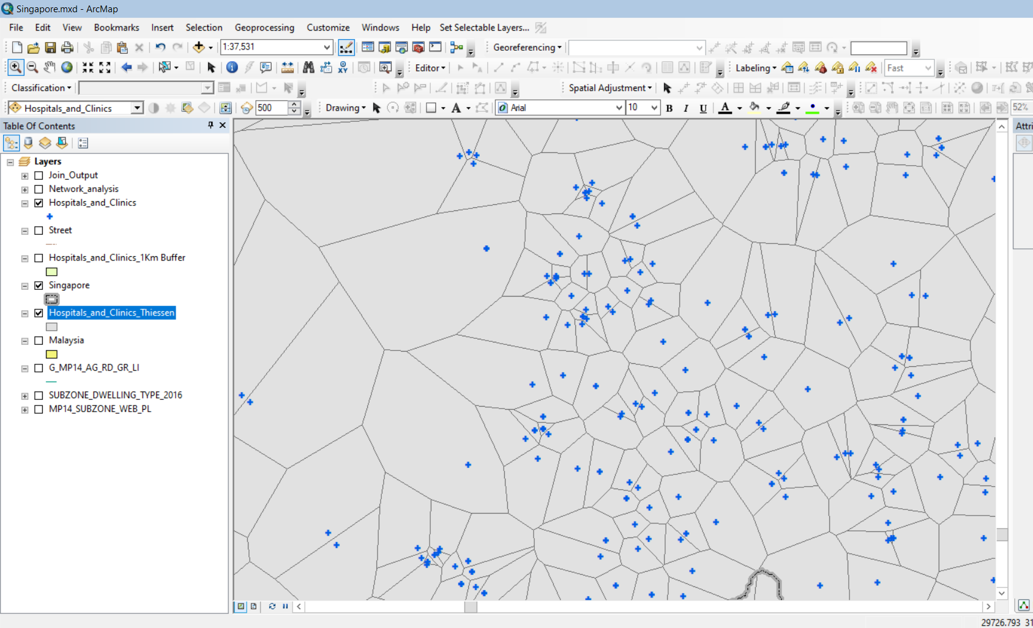
Figure 4: Hospitals and Clinics Thiessens
- The fourth outcome is a map of the health care facilities location with buffers with respect to the set administrative borders. In this study, we adopt 3 Km buffer as an ideal distance for considering adequate access to health facilities. The study analysis a buffer of 3000 meters (3Km from the health facility to delineate a uniform space of the service area for health care. The 3 Km buffer region serves a population of about 44284 people adequately. Notably, the 3 Km buffer is within a ten minute walking distance and 1- 3 minute response by driving assuming a speed of 25 km/hr. which is adequate time for responding to an emergency.
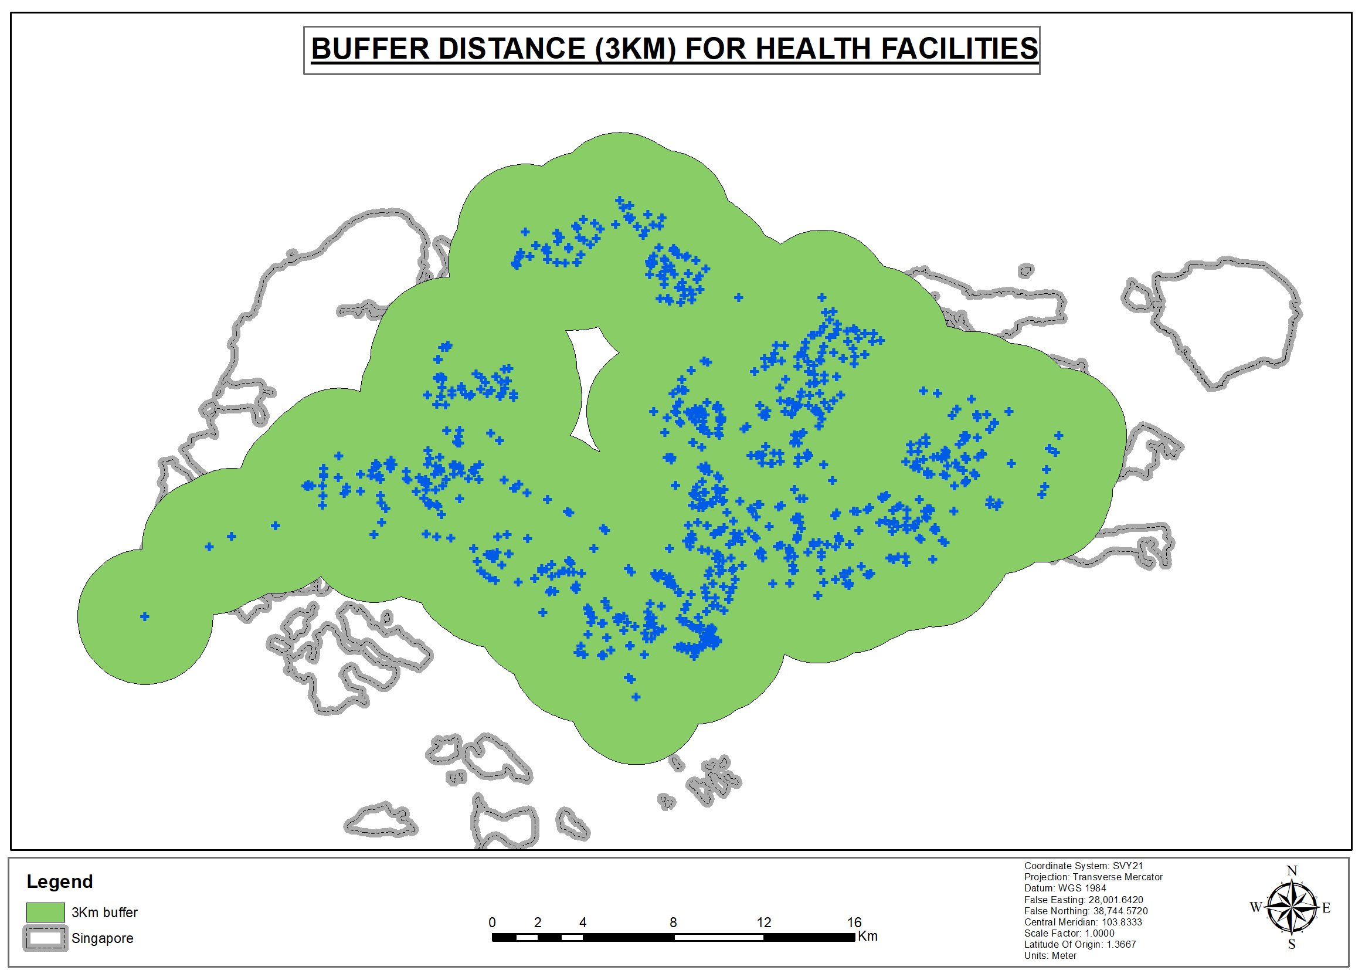
Figure 5: Buffer distance for health clinics.
- To conduct a Road Network Analysis to analyze the optimal route which should be used in case of a medical emergency.
- Analyzing the areas that are adequately served and the underserved area. Using the proximity distance of 3 Km, the areas highlighted in orange in the map represent the adequately served areas within the distance. The unshaded area within the Singapore boundary is underserved according to our analysis and therefore there is need to take action in proposing facilities to reduce the spatial gaps. The analysis points out that the suitable area served 45,019 people adequately, which is higher than in the buffer analysis and more adequate.
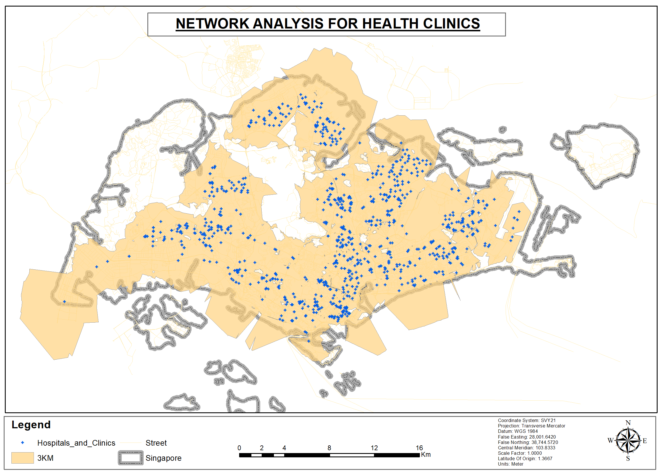
Figure 6:Network Analysis for Health Clinics
- Potential new areas where healthcare facilities are proposed in map are shown by the red dots. The proposed areas are marked as suitable location to reduce the spatial gap identified in exercise (a) above. The study limited the facility choice to 15, and the analysis ranks the first area for action having analyzed the gap and need for a new facility. The model can be used to plan for other facilities based on the demand and gaps identified with a practical application in the health sector.
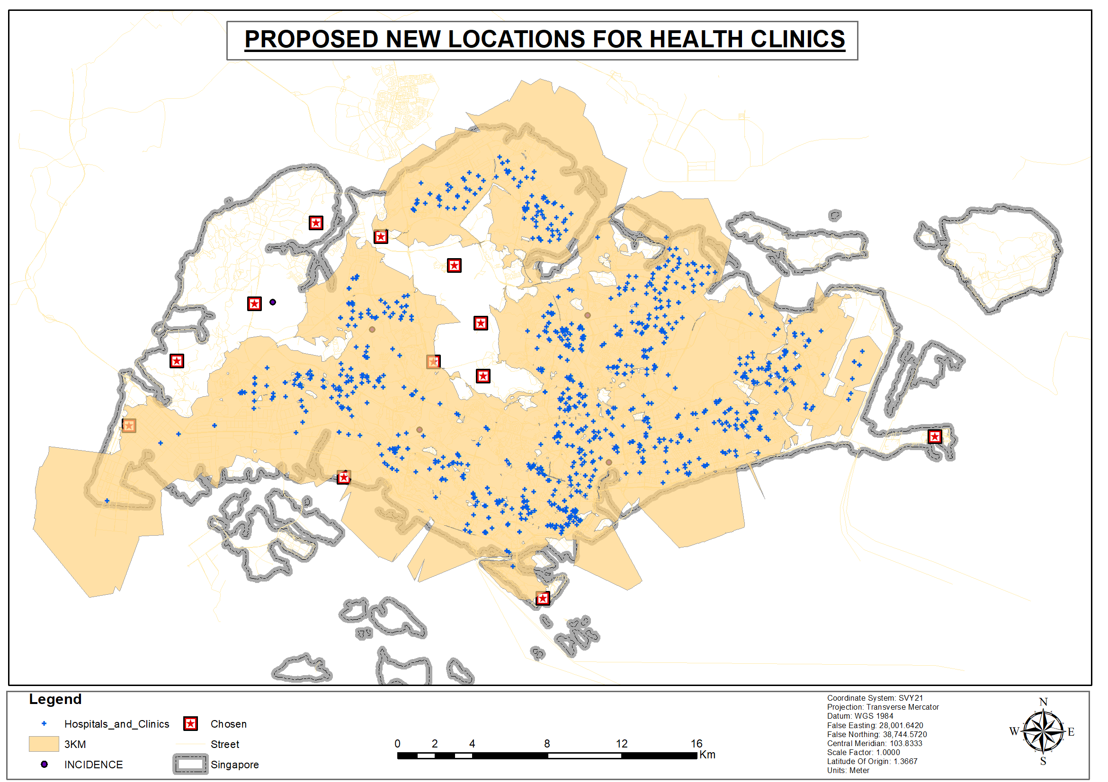
Figure 7: Proposed new locations for health clinics.
- A comprehensive route analysis will also be done to assess the optimal route which should be used in case of emergency situations in the country. This was achieved by creating “imaginary” potential incidence sites as indicated by the yellow boxes on the map below. The goal of the exercise is to identify the nearest facility to the incidence and define a suitable route for accessing the incident site. In this analysis, distance was used as the determining factor and the shortest route was adopted for the analysis, however, the scope can be extended to time and cost parameters for decision making.
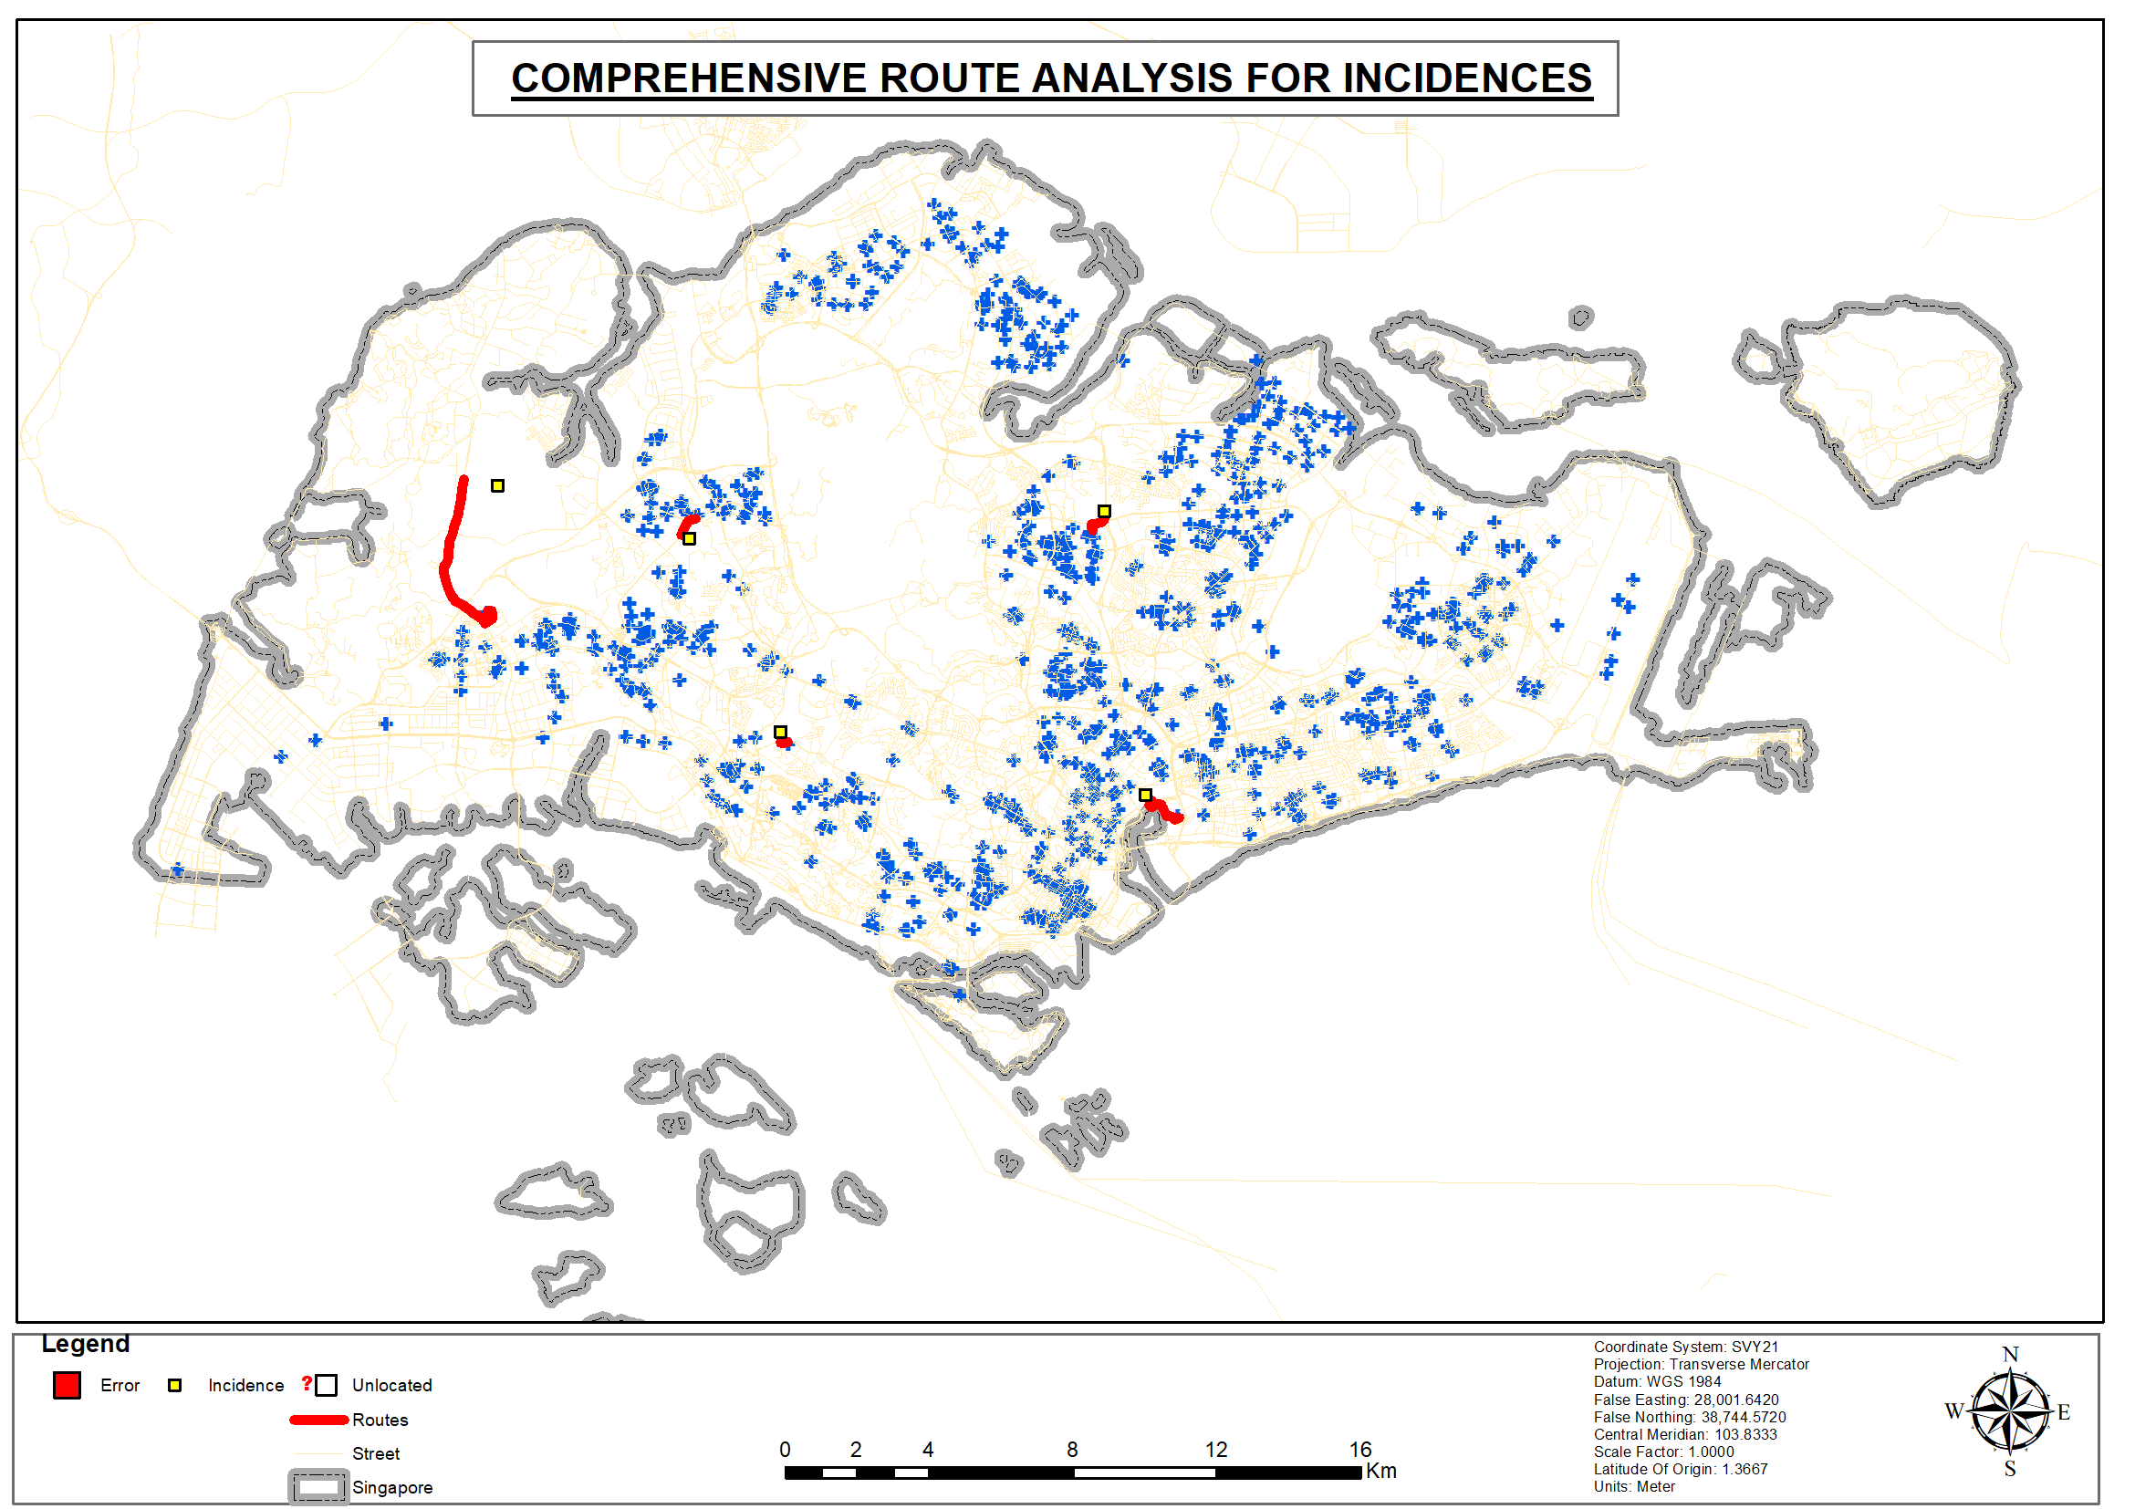
Figure 8: Comprehensive route analysis for incidences
The screenshot shows a detailed response of the queried data on the accessibility of the health facility. The red line highlights the most suitable route to the closest facility of the incidence.
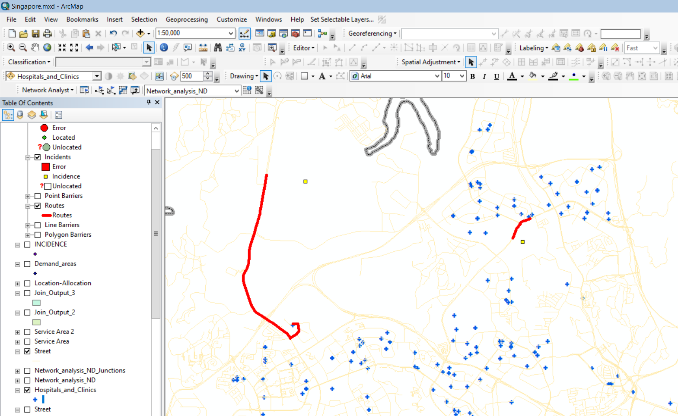
Figure 9: The most suitable route.

3.1 Discussion
Healthcare accessibility usually entails timely use of the health services in a country which helps in the attainment of the best health outcomes (Khoo, Lim & Vrijhoef, 2014). This paper served to assess the healthcare accessibility based on the geographic availability of the locations. Mapping of the health care infrastructure was very crucial in evaluating the distribution of the health care systems spatially. The results revealed an interesting trend. The south west region of the country had fewer clinics within its scope. Moreover, the number of public health facilities were minimal in the Northern West part of the country. The population data was very crucial in determining areas of deficiencies when it came to measuring accessibility. The population density based on the dwelling unit zones was vital in evaluating the demand and the supply of the healthcare services. The thiessen polygons provided a clear picture of areas which had more than one healthcare facility and those which had none. This was crucial in assessing the place where new healthcare facilities were needed.
The buffers were also used to perform reclassification based on distance. The buffering revealed interesting results in terms of classification within a given proximity. In case of a medical emergency, a road network analysis was effectively performed. This helped in analyzing the optimal route which should always be used when accessing the private and the public healthcare services. This helped in coming up with areas which are not adequately served. The GIS process helped us propose new areas where healthcare services are needed in Singapore. The results on the road analysis revealed that most of the healthcare services are accessible to the general public. This is in terms of the distance one had to travel and the roads connecting the healthcare institutions. However, new routes were proposed to those areas which were not accessible. This was after performing a thorough route analysis.

3.2 Evaluation
Research evaluation in most instances happens after the implementation of a given program. This helps in articulating the outcomes of a given program. In this research process, the accessibility outcome of the healthcare facilities was measured, described as well as understood. Good research principles were applied in the research process. This program hence helped in enhancing the accessibility of the health care services. Among the metrics which were crucial in evaluating the accessibility included the population data and the road network infrastructure. Even though most healthcare facilities were accessible, we had some which needed re-routing. The benefits which were realized from this research process was that the proposed solution ensured that all the healthcare facilities were now adequately accessible. The inequality in the healthcare services was hence reduced. The research assessment in this research process also considered the issue of sustainability.

4. Conclusion
In this analysis, the health sector was compared against distance, population on a general scale, service area in three aspects (Thiessen polygon, buffer and network analysis) and the analysis points to the decision making capabilities of network analysis in identifying gaps and underserved areas, and offer solution to suitable areas for locating new facilities. The analysis explored the diversity and usability of GIS system in heath sector to improve service delivery and decision making to improve health delivery. Overall, the study area points to a spatial relationship between health facilities and population served and the study identified that more facilities are located in areas with a high population density, that means a higher number of people is adequately served that could explain the high health status. Ideally, good health is not just a factor of spatial location but quality of service and there is room to explore other parameters that could enhance health by incorporating other related attributes.

4.0. Recommendations
The review of Singapore health system points out to the potential power of using geospatial technologies to improve decision making in the health sector. The analysis was done to understand trends in the health sector in terms of spatial distribution and to assess other cross data analysis that can be done on the data to enhance understanding of the pattern. Several gaps were identified in the analysis that when addressed it would improve the quality and capacity of the analysis.
- The health facility data provided does not factor in the entire private clinics. To enhance the health database, there is need to increase spatial data collection and the building of the database to incorporate data necessary for health analysis.
- Health facilities as well as the ministry of health should focus on building a health database with a variety of relevant attributes. These include name of facilities with details of the services offered, staff capacity, bed facility, room for expansion, ownership and status. This data is relevant in planning for changes in the health care, as income areas instead of building a new facility, the decision would be to increase the capacity of existing ones. Other attributes that such as finances, population served, typed of sicknesses treated among others can be collected and used in the analysis and decision making prices.

References
Abdelmajid, M., Apparicio, P., Riva, M., Shearmur, R., (18 February 2008). Comparing alternative approaches to measuring the geographical accessibility of urban health services: distance types and aggregation-error issues. International Journal of Health Geographics. 7:7.hhtps://doi.org/10.1186/1476- 072X-7-7
Goodchild, F., De Smith, G., and Longley, A. (2015). Geospatial Analysis, 5th Edition.
Haseltine, W. A. (2013). Affordable excellence: the Singapore healthcare story: how to create and manage sustainable healthcare systems. Brookings Institution Press.
Khoo, H. S., Lim, Y. W., & Vrijhoef, H. J. (2014). Primary healthcare system and practice characteristics in Singapore. Asia Pacific family medicine, 13(1), 8.
Kumar, A., Ozdamar, L., & Zhang, C. N. (2008). Supply chain redesign in the healthcare industry of Singapore. Supply Chain Management: An International Journal.
Wheeler, D. (2013). Statistical techniques in Geographical analysis. London: Routledge.
Yang, DH., Goerge, R. & Mullner, R. J Med Syst (June 2005). Comparing GIS-based methods of measuring spatial accessibility to health services. Journal of Medical Systems, vol30, no. 1, 2006, pp 23-32, doi:10.1007/s10916-006-74
Zhu, J. Y., & Protti, D. J. (2009). National health information management/information technology strategies in Hong Kong, Taiwan and Singapore. Studies in health technology and informatics, 143, 122-128

